ABWA MEDICAL COLLEGE,FAISALABAD

RESEARCH FORM FOR APPROVAL


By

Name of Main Researcher __________________________
______________________________( Designation)
_________________________________( Specialty)
OR

Batch No. ______( For Undergraduate students only)

Supervised By _____________________(Name of Mentor, if any)
_____________________(Designation)
_____________________(Specialty)

Names of Students and roll no. Class __________________

- _____________________________
- _____________________________
- _____________________________
- _____________________________
- _____________________________
- _____________________________


ABWA MEDICAL COLLEGE,FAISALABAD
Checklist for Submission for Research Approval

1. | Title of the study:
2. | Details of Principal Investigator:
 | Name: | ____________________________________
 | Designation: | ____________________________________
 | Department: | ____________________________________
 | Contact No: | ____________________________________
 | Email: | ____________________________________
_______________
Signature of Principal Investigator

Submission of Copies
Copies of the following documents must be submitted to Department of Medical Education and Research, Abwa Medical College, Faisalabad for review by first week of each month.
Research Proposal
Study Proforma
Informed Consent in English and/or Urdu, where required
Ethical Considerations Form
Research Approval Checklist

- Please note that the Investigator is required to present before the Institutional Review Board of Abwa Medical College, Faisalabad. The date of presentation shall be conveyed to the Investigator. The presentation should be brief, to the point of not more than 5-7 slides.
- Incomplete submissions, late, or on the spot submissions will not be entertained.

Title of Research Project:
Name , email address and Phone Number of Principal Researcher

Name of Research Supervisor/Mentor | Signature: | Date:
Name of Research Co-Supervisor – Co-mentor(if any) | Signature: | Date:
Name of Head of Department | Signature: | Date:
Name of Chairperson, Educational Research Committee | Signature: | Date:
Name of Chairperson, Institutional Review Board | Signature: | Date:
Please email your completed Research proposals (ERC form, IEC form , Study Questionnaire ) to Department of Medical Education and Research to Ms. Rabia ,
Email __________________________

In case of any query , please contact DME&R – Dr. Uzma Kausar and/or Dr.Noorikiran Haris.
Introduction (Limited to a single page)- Please remove the sentences in italics while writing your proposal.

Introduction should establish the basis of the research, in three paragraphs.

- Presentation of problem. State the research problems. First discuss
general issues and then outline more specific problems.

- Give short summary of current state of knowledge, gaps or controversy in existing knowledge or if there is inconclusive evidence. Investigator may have his own observations/reasons to question the existing knowledge that need to be verified.

- Clearly indicate reason for conducting the study, ending up with actually what has to be done (Objectives).
Literature Review:

Limit to 1-2 pages, describing at least 3 relevant studies
It should consist of three sections.
1.the first section should cover current state of knowledge, with gaps or controversy in existing knowledge or if there is inconclusive evidence.
2.2nd section should introduce the precise nature of the project;
3. the last section should describe quantifiable goals/objectives in the light of first two sections.

(References should be given in Vancouver style preferably from last five years. A few older references can be given only for historical purpose)

Research Question(s):

Research Objective(s):

Hypothesis:

Operational Definitions: (If applicable):

Materials/Subjects & Methods:
Patients/Experimental Animals Selection (Inclusion & Exclusion Criteria; attach all
proformas used for data collection at the end)

Study Design: _______________________________________

e.g., Randomized Control trial
Comparative study
Experimental study
Quasi Experimental study
Descriptive study

Setting: _________________________________________

Place, where study will be carried out.

Duration: _________________________________________

Anticipated duration of study for Postgraduate research should not be less than 12 months and that for undergraduate research is 6 months including the time taken for preparation of synopsis, its approval, procurements, conduct of research experiments including follow-up if any, to compilation of results and thesis writing.

Sample Size: _________________________________________

Sampling Technique: _________________________________________

Sample Selection: Inclusion criteria

___________________________________________

____________________________________________

Exclusion criteria
___________________________________________

____________________________________________

Methodology: (Data Collection Procedure)

Describe full methodology in the form of paragraph in this portion along Sample description with the setting, duration, and sample size study subject, sample technique selection of subject (Inclusion exclusion Criteria) study tools and methods of procedures.

Statistical Analysis:

Data recording, storage, assessment. How data will be analyzed? Software to be used. What parametric or nonparametric tests will be used for different variables i.e. level of significance? How the conclusion will be drawn?

Choose appropriate tests for analysis from below after discussion with your supervisors
Statistical analysis will be conducted on SPSS 20 Software by using
Means± SD for descriptive continuous variables
Frequency and percentages for categorical variables (gender etc)
ANOVA for comparison of mean for more than two groups
T test for comparison mean for of 2 groups
Pearson’s Correlation for association
Chi square for comparison of categorical data (percentages)
The level of significance will be taken as p<0.05

Outcome & Utilization:

Describe in which way the expected results of your study can be useful in designing and delivery of health care system

Limitation of the proposed study:

Briefly describe study limitations anticipated at the outset, especially constraints relating to sample size, sample selection, methodology, procedure, and other practical or financial constraints, keeping in view the similar studies conducted earlier.

References:

Latest, preferably those published in last five years. To be given in an alphabetical order in hanging margins, without serial numbers or bullets. All in-text references should be cited in bibliography

Note: The prescribed referencing style has been Vancouver Style.
Format for References
Journal Article

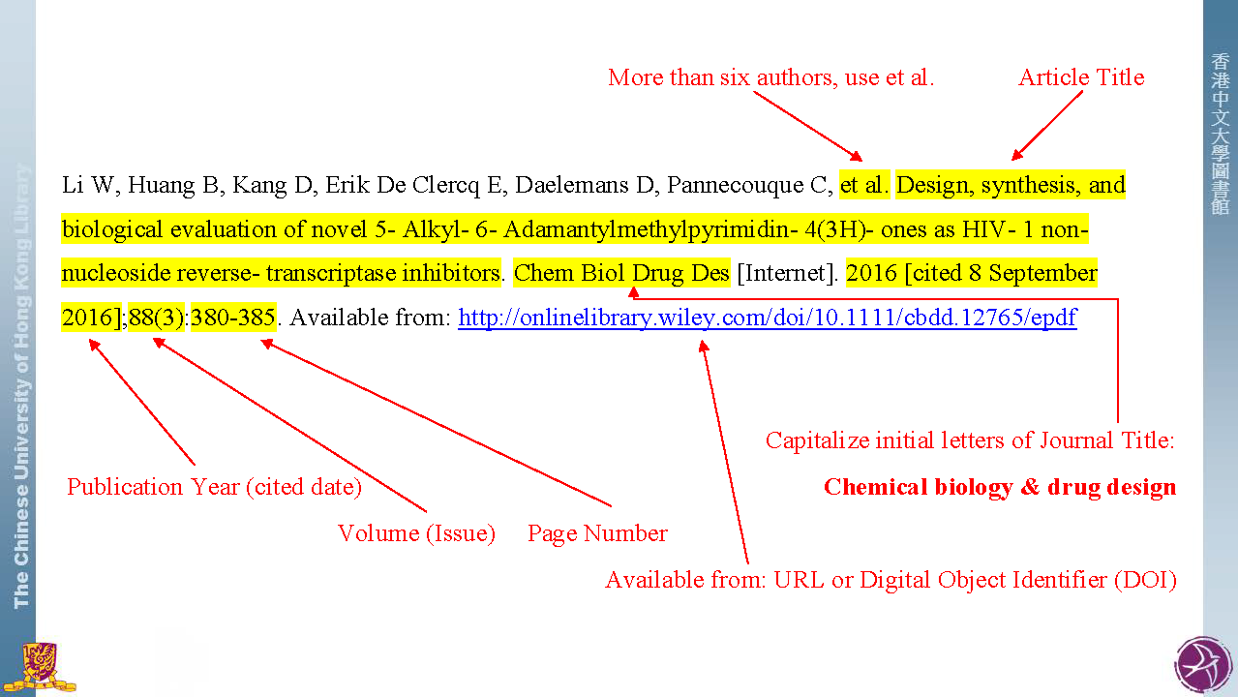

Book

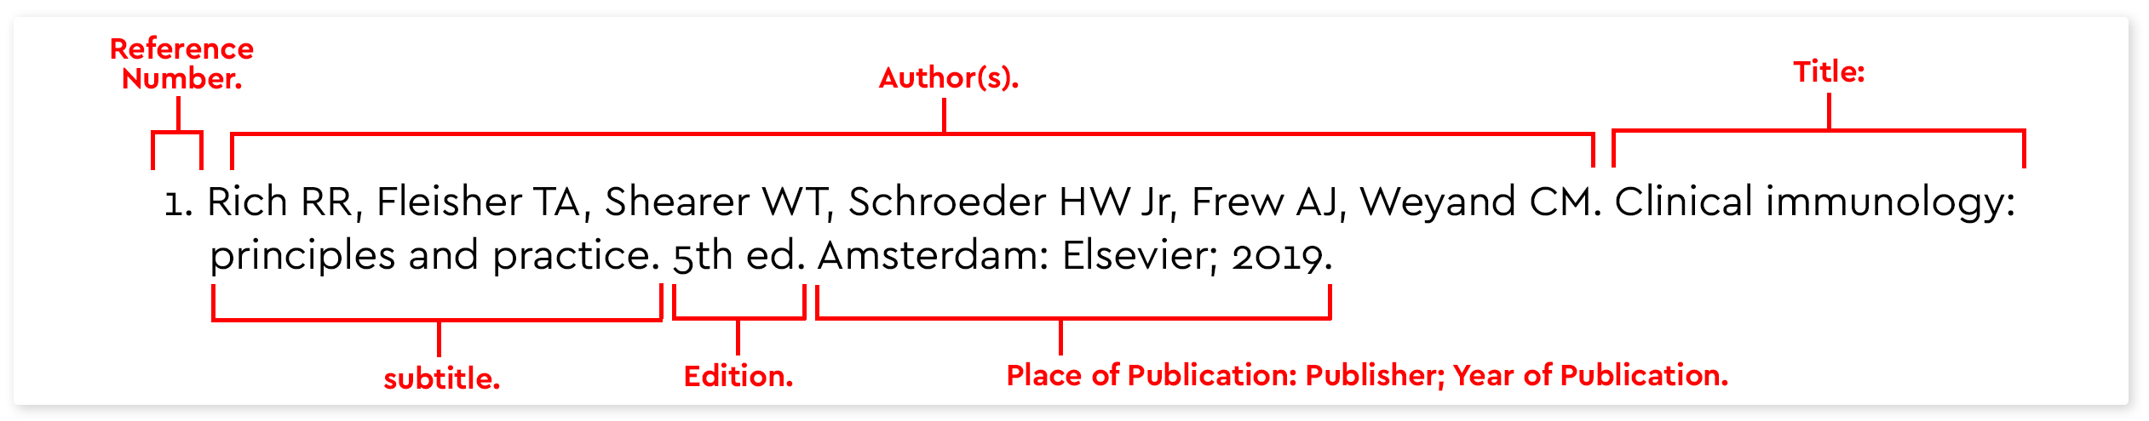

For in-text citation



Annexures: Including:

- Ethical Considerations (duly signed by the candidate and the supervisor)
- Informed Consent Proforma (English & Urdu Translations)
- Estimated Cost of the Project: which includes the funds required for all chemicals / reagents, laboratory equipment/ materials or study animals (if any) to be utilized in the research needs. Cost estimate should be given in an itemized, tabulated format, including all direct and indirect costs.
- Plan of work (Gantt Chart): Schedule/Phasing (In order to achieve the desired objectives of the study, divide your work plan into different phases in a tabular form)
- Any other including Data Collection proformas, Questionnaire, Survey or another data collection tool, etc.

ANNEXURE

ABWA MEDICAL COLLEGE,FAISALABAD
Ethical Considerations
1. | Proposed research study involves the use of:  (Please fill the box with black color if macros do not work, as appropriate)
 |  |  | Experimental Drug(s) |  |  |  |  | Non-therapeutic research
 |  |  | Radioactive agents |  |  |  |  | Experimental Surgical procedure
 |  |  | Behavioral research |  |  |  |  | Community research
 |  |  | Others (please specify): |  | ______________________________________________
2. | Do your research study involve following subjects:  (Please fill the box with black color if macros do not work, as appropriate) |  |  |  |  |  |  |  |  |  |  | Yes |  |  | No
 |  | Pregnant women |  |  |  |  | Children |  |  |  |  |  | Elderly
 |  | Illiterate |  |  |  |  | Fetus |  |  |  |  |  | Handicapped
 |  | Terminally ill |  |  |  |  | Poor |  |  |  |  |  | Mentally challenged
3. | Duration of the study: |  |  |  | ___________________________________
4. | Information about the sponsor(s) N/A
 | Name & Address
 | Amount Demanded/approved*
 | Amount PI will receive (p/m)
 | Incentive for the participants:
 | *Detailed budget must also be attached with the application in case of any sponsorship.
5. | Is there any diagnostic test (s), part of your research studies, which are not routinely done in the laboratory? If “Yes”, please give detail. Please also mention who will bear the expenses.
6. | How will participants benefit from this research?
7. | How will the institution benefit from this research?
8. | What are the risks/adverse effects possible to the research?
9. | If adverse events happen, who would be responsible for managing them? Please give contact detail.

ABWA MEDICAL COLLEGE,FAISALABAD
Informed Consent- English

Research Description
Title of the Study
Name of the Investigator
Name of organization
Source of Funding
Duration of the study
Purpose of the Study
Methodology
Confidentiality
Possible Benefits to the Research Participants
Possible Risks to the Research Participants
Right to Refuse to Participants and Withdrawal
For Further Information
Undertaking: I have read this consent form and fully understood it. I volunteer to participate in this research study. I understand that I will receive a copy of this form. I voluntarily choose to participate, but I understand that my consent does not take away any legal rights in the case of negligence or other legal fault of anyone who is involved in this study. I further understand that nothing in this consent form is intended to replace any applicable Federal/Provincial laws.

__________________________ _____________________________
Participant’s Name & Signature/ Signature of the Witness in case of
Thumb impression Thumb impression

____________________________ ______________________________
Signature of Investigator and Date Signatures of the Supervisor and date

ABWA MEDICAL COLLEGE,FAISALABAD
Informed Consent- Urdu
اجازت نامہ
محکمہ کا نام:
مطالعہ کا عنوان:
______________________________________________________________________________________________________________________________________________________________
مجھے ولد / زوجہ

کو اوپر کے عنوان کے تحقیقی منصوبے میں تجویز کردہ طریقہ کار اور طریقہ کار کے بارے میں تفصیل سے آگاہ کیا گیا ہے۔
اس کی پیچیدگیوں / نتائج کے ساتھ ، مجھے مطلع کیا گیا ہے کہ تفصیلات کو خفیہ رکھا جائے گا اور صرف تحقیقی مقصد کے لیے استعمال کیا جائے گا۔ مجھے یہ بھی بتایا گیا ہے کہ یہ تحقیق صرف ایک فرد کے لیے نہیں بلکہ بڑے پیمانے پر انسانیت کے لیے ہے۔ میں محقق کی دی گئی ہدایات پر عمل کروں گا۔ میں اس کے بارے میں کوئی سوال پوچھ سکتا ہوں اور میرے سوالات کے جوابات میرے اطمینان کے لیے دیے گئے ہیں۔ میں رضاکارانہ طور پر رضامندی سے اپنے کو مطالعے میں ایک مضمون سمجھتا ہوں اور میں سمجھتا ہوں کہ مجھے کسی بھی وجہ کی وضاحت کیے بغیر کسی بھی وقت مطالعے سے دستبردار ہونے کا حق ہے اور ایسی صورت میں بھی مجھے دوسرے کی طرح سلوک کرنے سے انکار نہیں کیا جائے گا- میں ڈاکٹر کو اجازت دیتا ہوں کہ اس مطالعے میں مجھے ہ شامل کریں۔
نام:
مریض کا ہسپتال رجسٹریشن/داخلہ نمبر:
مریض / سرپرست کے دستخط: ڈاکٹر / محقق کے دستخط۔:
تاریخ:

ABWA MEDICAL COLLEGE,FAISALABAD
Plan of Work- Gantt Chart

Activities | Months – for 6 months research
Activities | 1 |  | 2 |  | 3 |  | 4 |  | 5 |  | 6
Proposal writing
Obtaining Ethical Approval
Planning for data collection
Data collection
Data entry
Data analysis and interpretation
Article writing
Artcile publication

____________________________________________________________
Budget
A. Expendable items

Item needed | Cost price | Sample | Total

B. Stationery items

Item needed | Cost price | Total

ABWA MEDICAL COLLEGE,FAISALABAD
Study Proforma
Title _______________________________________________________
Please copy-paste your study proforma here- Sample given below – please remove when editing
Date ____________ Group A / B

Demographic Details
Name:_________________ Age:_______ Hospital No:________ Case No:______
Residential Address:__________________________ Contact Number:_____________
Married : Yes / No Kids: Yes/No/Not Applicable
Presenting Diagnosis _____________________ Date of Presentation:_____________
Place of living: rural / urban Education level: illiterate/primary/middle/matric/graduate
Measurable Variable in study
Measures | Outcomes | Values | Baseline | Month 3 |  | Month 4 | Month 6
Anthropometric Measurement | Body Mass Index | Body weight ( kg)
Anthropometric Measurement | Body Mass Index | Height ( m)
Anthropometric Measurement | Body Mass Index | BMI ( kg/m²)
Anthropometric Measurement | Waist- hip ratio | Waist circumference  ( cm)
Anthropometric Measurement | Waist- hip ratio | Hip circumference  ( cm)
Anthropometric Measurement | Waist- hip ratio | Waist-hip ratio
Menstrual Cycle Regulation Profile | Menstrual Cycle Duration | Duration ( days)
Menstrual Cycle Regulation Profile | Menstrual Cycle Frequency | Frequency occurrence  ( days)

